**ASSIGNMENT 11**

**A record company wishes to use a computer database to help with its operations regarding its performers, recordings and song catalogue. A requirements analysis has elicited the following information: Songs have a unique song number, a non-unique title and a composition date. A song can be written by a number of composers; the composer’s full name is required. Songs are recorded by recording artists (bands or solo performers). A song is recorded as a track of a CD. A CD has many songs on it, called tracks. CDs have a unique record catalogue number, a title and must have a producer (the full name of the producer is required). Each track must have the recording date and the track number of the CD. A song can appear on many (or no) CDs, and be recorded by many different recording artists. The same recording artist might re-record the same song on different CDs. A CD must have only 1 recording artist appearing on it. CDs can be released a number of times, and each time the release date and associated number of sales is required.**

1. **Use this information to design an appropriate ER and relational model.**
2. **Compile DDL and DML commands on the database created.**

**SQL: -**

**i.Update number of recorded albums to 4 for those artists who has recorded only 3.**

**ii.Find all artists who have recorded at least two albums.**

**iii.Find all writers who have only written one song.**

**PL/SQL: -**

**i.Write Procedure to insert a new Contract into the Contract relation.**

* **ER DIAGRAM:**

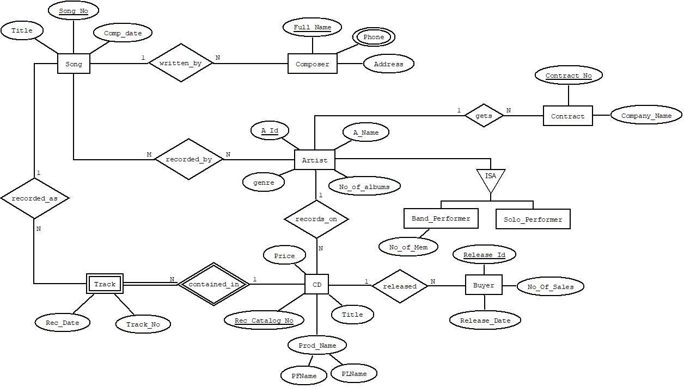

* **RELATIONAL MODEL:**

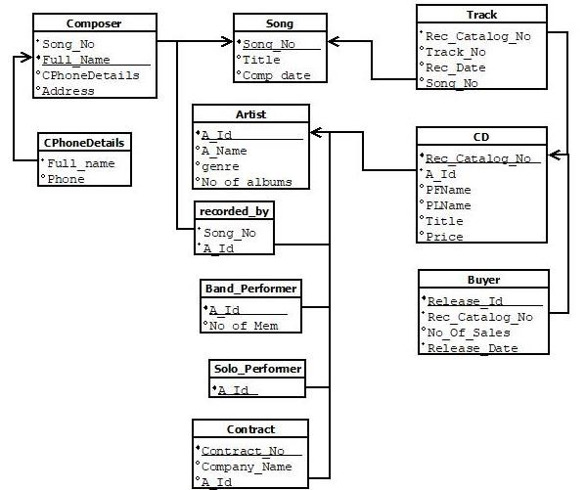

* **ASSUMPTIONS:**
* A song can be written many composers.
* Many songs are recorded by many different artists.
* An Artist (generalized entity) can be specialized into two types - Band Performer and Solo Performer.
* A song can be recorded in various tracks of different CDs.
* A CD contains many tracks. As a track cannot exists without CD, track becomes a weak entity.
* An artist can record his songs on various CDs.
* A CD can have songs of only one artist.
* A CD is released many times to buyer or market.
* An artist can get many contracts from same or different companies.
* An artist can have any number of albums recorded by him.

* **CREATE TABLE**

CREATE TABLE SONG(SONG_NO VARCHAR2(10) PRIMARY KEY NOT NULL,

TITLE VARCHAR2(20), COMP_DATE DATE);

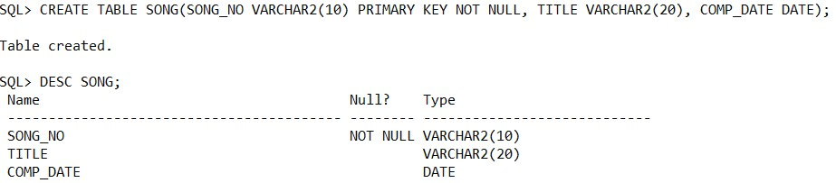

CREATE TABLE COMPOSER(FULL_NAME VARCHAR2(20) PRIMARY KEY NOT

NULL, SONG_NO REFERENCES SONG(SONG_NO), PHONE NUMBER(12),

ADDRESS VARCHAR2(20));

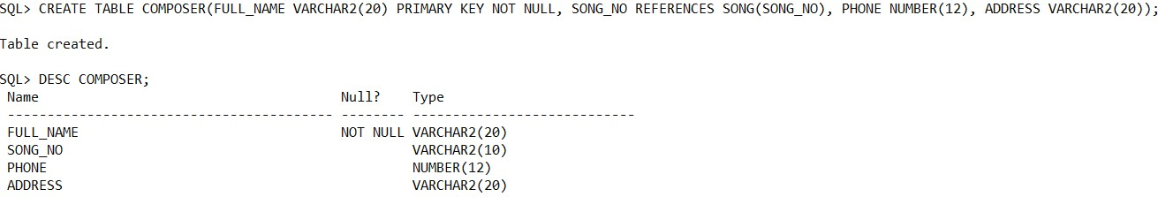

CREATE TABLE ARTIST(A_ID VARCHAR2(10) PRIMARY KEY NOT NULL,

A_NAME VARCHAR2(20), GENRE VARCHAR2(15));

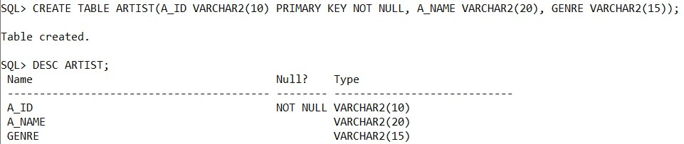

CREATE TABLE RECORDED_BY(SONG_NO REFERENCES SONG(SONG_NO) ON

DELETE CASCADE, A_ID REFERENCES ARTIST(A_ID) ON DELETE CASCADE);

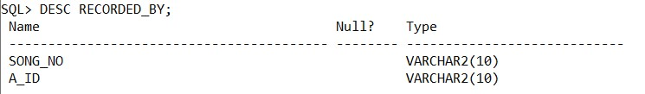

CREATE TABLE BAND_PERFORMER(A_ID REFERENCES ARTIST(A_ID) ON

DELETE CASCADE);

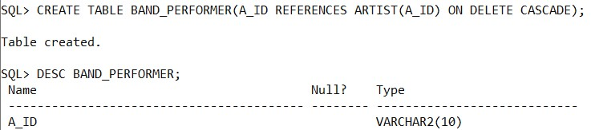

CREATE TABLE SOLO_PERFORMER(A_ID REFERENCES ARTIST(A_ID) ON

DELETE CASCADE);

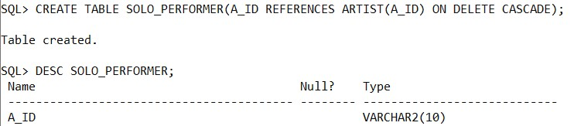

CREATE TABLE CD(REC_CATALOG_NO VARCHAR2(10) PRIMARY KEY NOT

NULL, A_ID REFERENCES ARTIST(A_ID) ON DELETE CASCADE, PFNAME

VARCHAR2(10), PLNAME VARCHAR2(10), TITLE VARCHAR2(20));

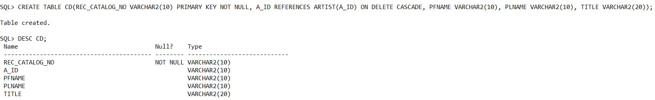

CREATE TABLE TRACK(REC_CATALOG_NO REFERENCES

CD(REC_CATALOG_NO) ON DELETE CASCADE, TRACK_NO NUMBER(4),

REC_DATE DATE, SONG_NO REFERENCES SONG(SONG_NO) ON DELETE

CASCADE);

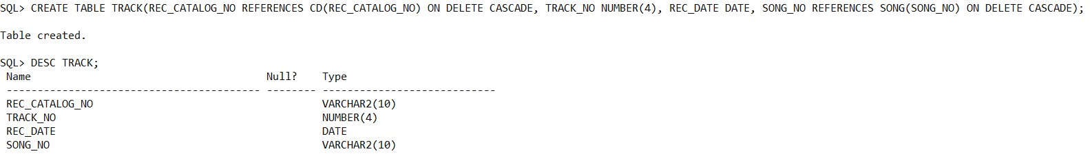

CREATE TABLE BUYER(RELEASE_ID VARCHAR2(10) PRIMARY KEY NOT NULL,

REC_CATALOG_NO REFERENCES CD(REC_CATALOG_NO) ON DELETE

CASCADE, NO_OF_SALES NUMBER(10), RELEASE_DATE DATE);

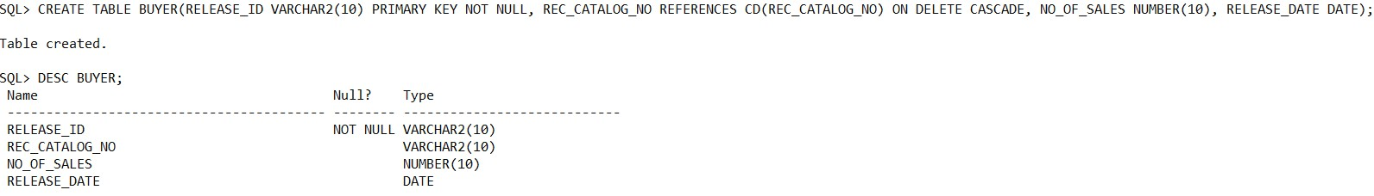

* **INSERT DATA**

INSERT INTO SONG VALUES('S010','TUM HI AANA','20-FEB-2020');

INSERT INTO SONG VALUES('S011','PACHTAOGE','27-NOV-2019');

INSERT INTO SONG VALUES('S012','SHAITAN KA SAALA','10-OCT-2019');

INSERT INTO SONG VALUES('S013','GHUNGROO','18-DEC-2019');

INSERT INTO SONG VALUES('S014','MUQABLA','05-JAN-2020');

INSERT INTO SONG VALUES('S015','DHEEME DHEEME','15-SEP-2019');

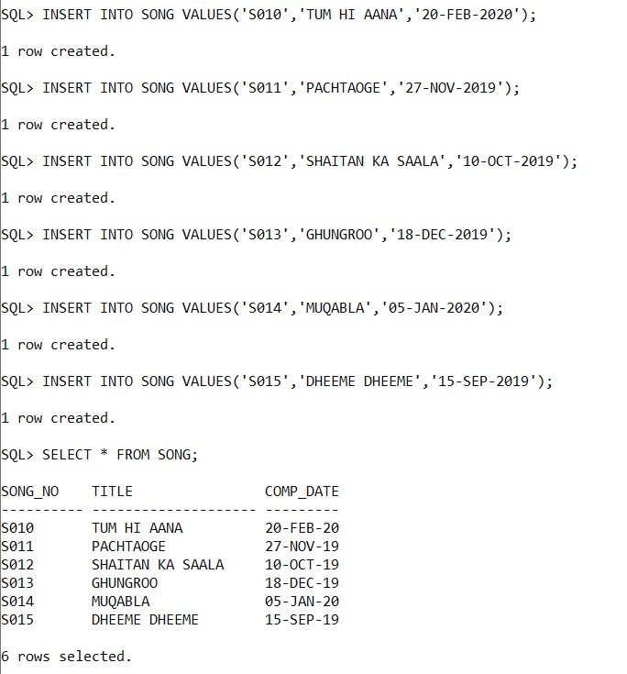

INSERT INTO COMPOSER VALUES('KUNAL VERMA','S010',9786754325,'12 MG ROAD MUMBAI');

INSERT INTO COMPOSER VALUES('VICKY KAUSHAL','S011',9587218760,'PARK STREET, KOLKATA');

INSERT INTO COMPOSER VALUES('SOHAIL SEN','S012',8583016253,'163 GT ROAD DELHI');

INSERT INTO COMPOSER VALUES('VISHAL SINGH','S013',8238167530,'16 LEE

ROAD JAIPUR');

INSERT INTO COMPOSER VALUES('PARAMPARA

THAKUR','S014',9339865748,'NEW ROAD AHMEDABAD');

INSERT INTO COMPOSER VALUES('AAKASH JAISWAL','S015',9375608651,'67 AJC

ROADMUMBAI');

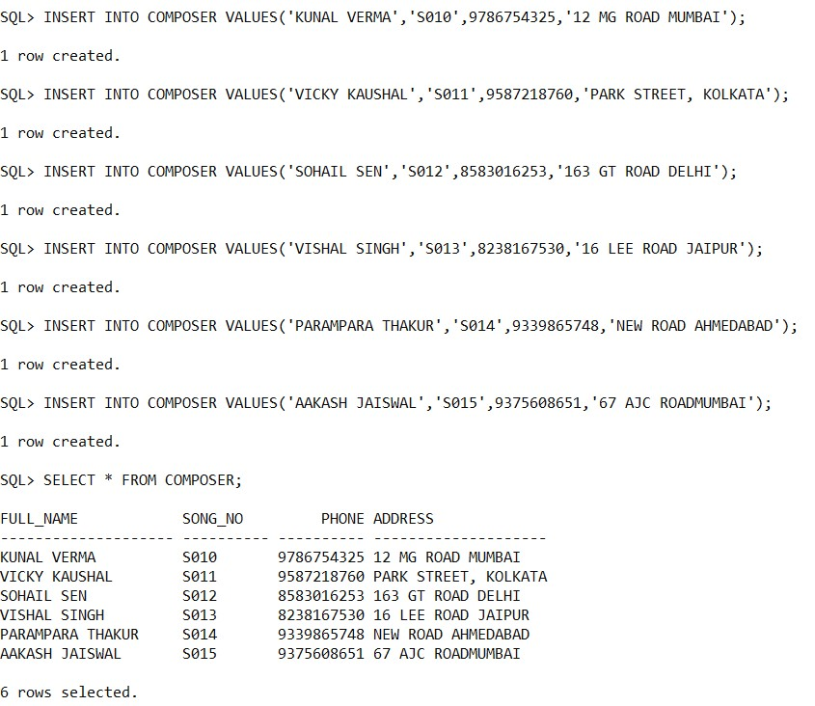

INSERT INTO ARTIST VALUES('A010','JUBIN NAUTIYAL','RHYTHM');

INSERT INTO ARTIST VALUES('A011','ARIJIT SINGH','JAZZ');

INSERT INTO ARTIST VALUES('A012','VISHAL DADLANI','ROCK MUSIC');

INSERT INTO ARTIST VALUES('A013','VED SHARMA','DANCE');

INSERT INTO ARTIST VALUES('A014','TONY KAKKAR','');

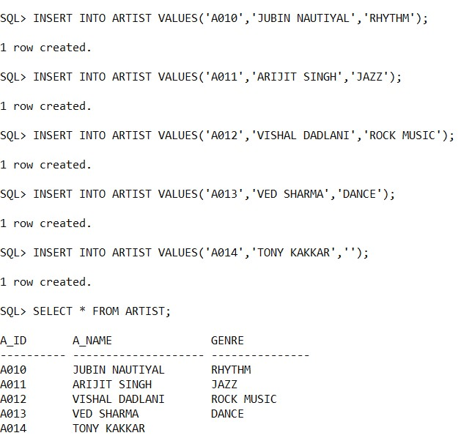

INSERT INTO RECORDED_BY VALUES('S010','A010');

INSERT INTO RECORDED_BY VALUES('S011','A011');

INSERT INTO RECORDED_BY VALUES('S012','A012');

INSERT INTO RECORDED_BY VALUES('S013','A011');

INSERT INTO RECORDED_BY VALUES('S014','A013');

INSERT INTO RECORDED_BY VALUES('S015','A014');

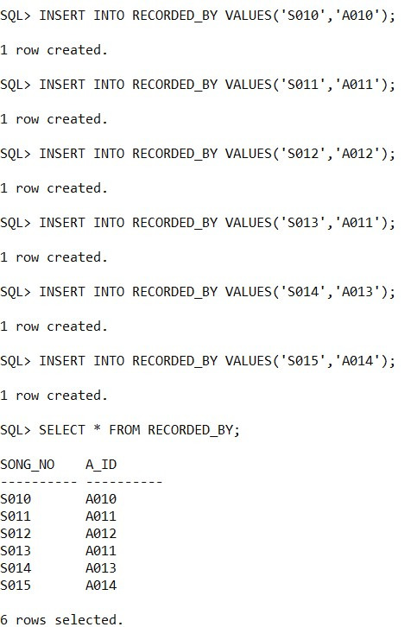

INSERT INTO BAND_PERFORMER VALUES('A010');

INSERT INTO BAND_PERFORMER VALUES('A012');

INSERT INTO BAND_PERFORMER VALUES('A013');

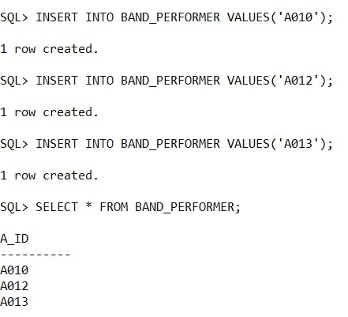

INSERT INTO SOLO_PERFORMER VALUES('A011');

INSERT INTO SOLO_PERFORMER VALUES('A014');

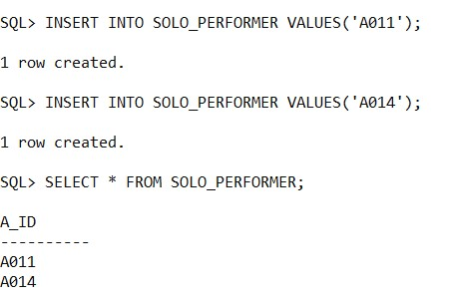

INSERT INTO CD VALUES('CD01','A011','MUKESH','SINGH','LATEST MUSIC 2020'); INSERT INTO CD VALUES('CD02','A012','VISHAL','PAUL','DANCE MUSIC');

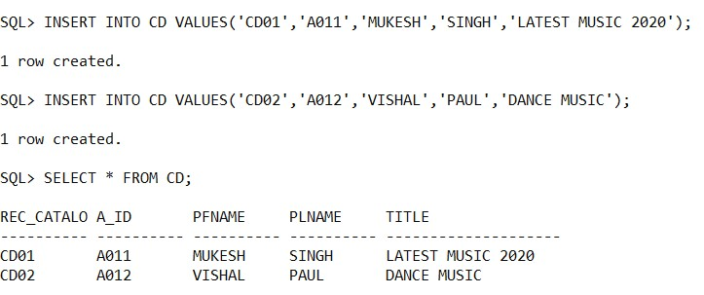

INSERT INTO TRACK VALUES('CD01',1,'14-FEB-2020','S011');

INSERT INTO TRACK VALUES('CD01',2,'14-MAR-2020','S013'); INSERT INTO TRACK VALUES('CD02',5,'14-DEC-2019','S012');

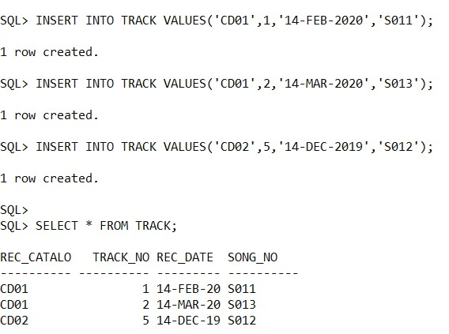

INSERT INTO BUYER VALUES('B01','CD01',1000,'13-APR-2020'); INSERT INTO BUYER VALUES('B02','CD02',500,'01-JAN-2020');

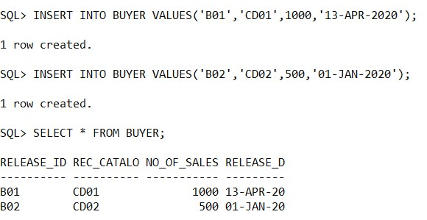

DELETE FROM ARTIST;

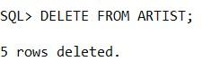

ALTER TABLE ARTIST ADD NO_OF_ALBUMS NUMBER(5);

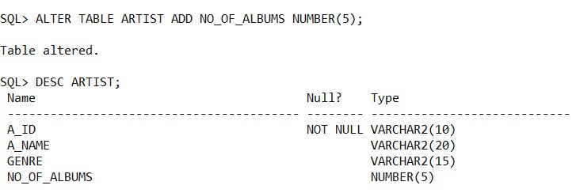

INSERT INTO ARTIST VALUES('A010','JUBIN NAUTIYAL','RHYTHM',3);

INSERT INTO ARTIST VALUES('A011','ARIJIT SINGH','JAZZ',1);

INSERT INTO ARTIST VALUES('A012','VISHAL DADLANI','ROCK MUSIC',2);

INSERT INTO ARTIST VALUES('A013','VED SHARMA','DANCE',4);

INSERT INTO ARTIST VALUES('A014','TONY KAKKAR','ELECTRO',0);

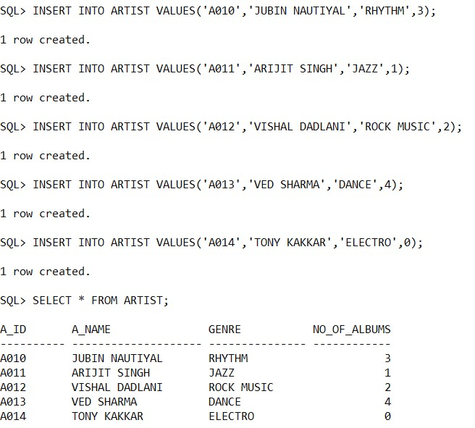

CREATE TABLE CONTRACT(CONTRACT_NO VARCHAR2(10) PRIMARY KEY NOT

NULL, COMPANY_NAME VARCHAR2(15), A_ID REFERENCES ARTIST(A_ID) ON

DELETE CASCADE);

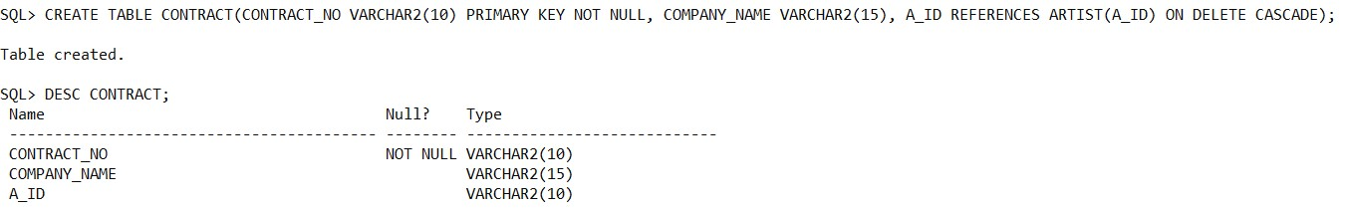

INSERT INTO CONTRACT VALUES('CON01','WYNK MUSIC','A012');

INSERT INTO CONTRACT VALUES('CON02','MAGIC MUSIC','A012');

INSERT INTO CONTRACT VALUES('CON03','SONIC SOUNDS','A011');

INSERT INTO CONTRACT VALUES('CON04','VECTOR VOLUME','A010');

INSERT INTO CONTRACT VALUES('CON05','VECTOR VOLUME','A014');

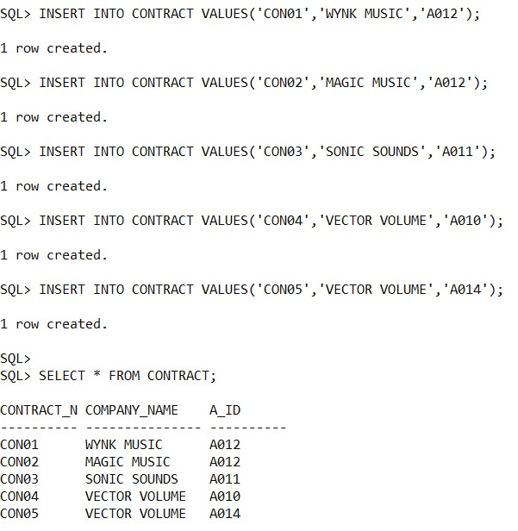

* **SQL:**

1. **Update number of recorded albums to 4 for those artists who has recorded only 3.**

UPDATE ARTIST SET NO_OF_ALBUMS=4 WHERE NO_OF_ALBUMS=3;

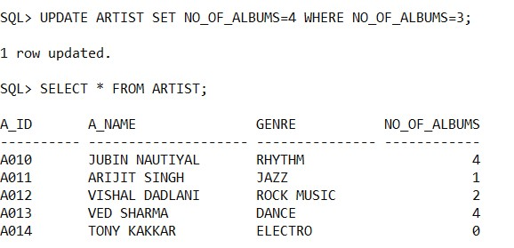

1. **Find all artists who have recorded at least two albums.**

SELECT * FROM ARTIST WHERE NO_OF_ALBUMS>=2;

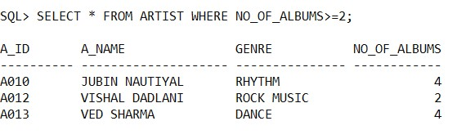

1. **Find all writers who have only written one song.**

SELECT FULL_NAME FROM COMPOSER GROUP BY FULL_NAME HAVING COUNT(SONG_NO) = 1;

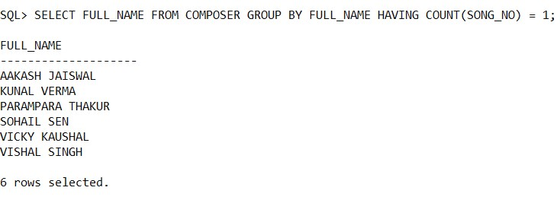

* **PL/SQL block to insert a new Contract into the Contract relation:**

DECLARE

c_contract_no contract.contract_no%type; c_company_name contract.company_name%type;

c_a_id contract.a_id%type; total_rows number(2);

valid number(2);

BEGIN

c_contract_no:=&contract_no; c_company_name:=&company_name; c_a_id:=&a_id;

--inserting a value in contract table

insert into contract values(c_contract_no,c_company_name,c_a_id);

EXCEPTION

WHEN others THEN

dbms_output.put_line('Error!');

END;

/

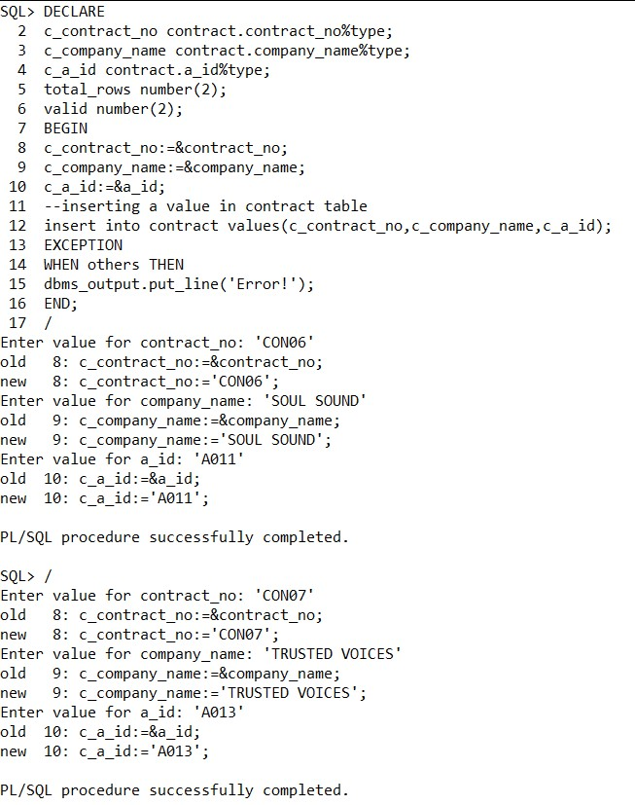

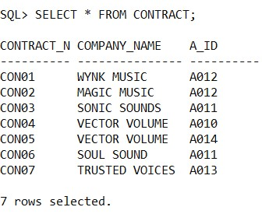

**PL/SQL: Procedure to insert a new Contract into the Contract relation:**

CREATE OR REPLACE PROCEDURE INS_CONTRACT

(A IN VARCHAR2,B IN VARCHAR2,C IN VARCHAR2) IS BEGIN

INSERT INTO CONTRACT VALUES(A,B,C);

END;

/

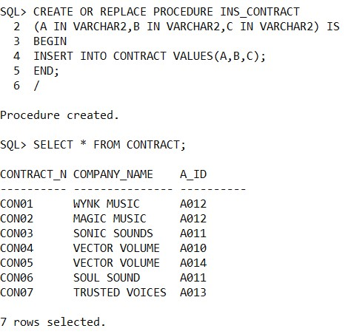

DECLARE

C_CONTRACT_NO CONTRACT.CONTRACT_NO%TYPE;

C_COMPANY_NAME CONTRACT.COMPANY_NAME%TYPE;

C_A_ID CONTRACT.A_ID%TYPE;

BEGIN

C_CONTRACT_NO:=&CONTRACT_NO;

C_COMPANY_NAME:=&COMPANY_NAME;

C_A_ID:=&A_ID;

--INSERTING A VALUE IN CONTRACT TABLE USING PROCEDURE INS_CONTRACT(C_CONTRACT_NO,C_COMPANY_NAME,C_A_ID);

EXCEPTION

WHEN OTHERS THEN

DBMS_OUTPUT.PUT_LINE('ERROR!');

END;

/

